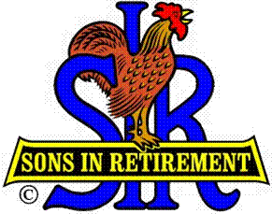

Las Trampas Branch 116

Luncheon Meeting Agenda

January 15, 2018

11:30 AM
- Call to Order – Big Sir.
- Welcome
- Pledge of Allegiance.
- Invocation: Dave Williams
- Introduce Head Table
- Little Sir: Jerry Hicks
- Guest Speaker – Monica Sanders “First Tee”
- Introduce Guests & Visitors
- Guests:
- Past Big SIRS – Please Stand to be reconized
- Visitors:
- Introduce New Members (if any)
- Big Sir Comment
- STATE OF THE UNION

11:45 PM – Lunch
- Raffle Drawing
- Sunshine Report

12:15 PM
- Committee Reports
- Golf Presentations, Bernie Wroblewski, Commissioner and Dick Chaffee, 9 Hole Group

12:30 PM
Little Sir:
- Introduce Guest Speaker – Monica Sanders – FIRST TEE.
- Ask November Birthday guys to stand / sing Happy Birthday (Paul King & Robbie)
- Sign God Bless America.

